

COMSATS UNIVERSITY ISLAMABAD, ATTOCK CAMPUS

Computer Science Department

DATA STRUCTURES & ALGORITHMS

PROJECT TITLE: CALCULATOR APP

SUBMITTED TO:
MAAM MARIYUM BUKHARI

SUBMITTED BY:
ZAINAB KHAN (FA22-BSE-032)

DATE OF SUBMISSION :
21ST MAY,2024
DESCRIPTION:
Asimple calculator that evaluates arithmetic expressions using a doubly linked list and a custom stack. Here's a brief overview:
- Node Class: Represents a node in a doubly linked list, holding a character and pointers to the previous and next nodes.
- Stack Node Class: Represents a node in a stack, holding an integer and a pointer to the next node.
- Custom Stack Class: Implements a stack with basic operations like push, pop, peek, and isEmpty.
- Calculator Class: Manages the linked list of characters representing the arithmetic expression and performs the calculation. It has methods to append characters to the list, calculate the result, and clear the list.
- Main Method: Continuously takes user input for arithmetic expressions, processes the input, and prints the result. The user can clear the calculator by entering "clear" or "0".

Data Structures Used
- Doubly Linked List:
  - Used in the Calculator class to store the arithmetic expression.
  - Each Node object contains a character from the expression and pointers to the previous and next nodes.
- Custom Stack:
  - Used in the Calculator class to evaluate the arithmetic expression.
  - The Custom Stack class uses Stack Node objects to hold integer values and provides stack operations like push, pop, peek, and isEmpty.

Key Functionalities
- Appending Characters: Characters from the input expression are appended to the doubly linked list.
- Expression Validation: Validates the input expression to ensure it contains only digits and arithmetic operators.
- Calculation: Evaluates the arithmetic expression using the custom stack to handle operators and operands.
- Clearing: Clears the linked list, resetting the calculator for new input.
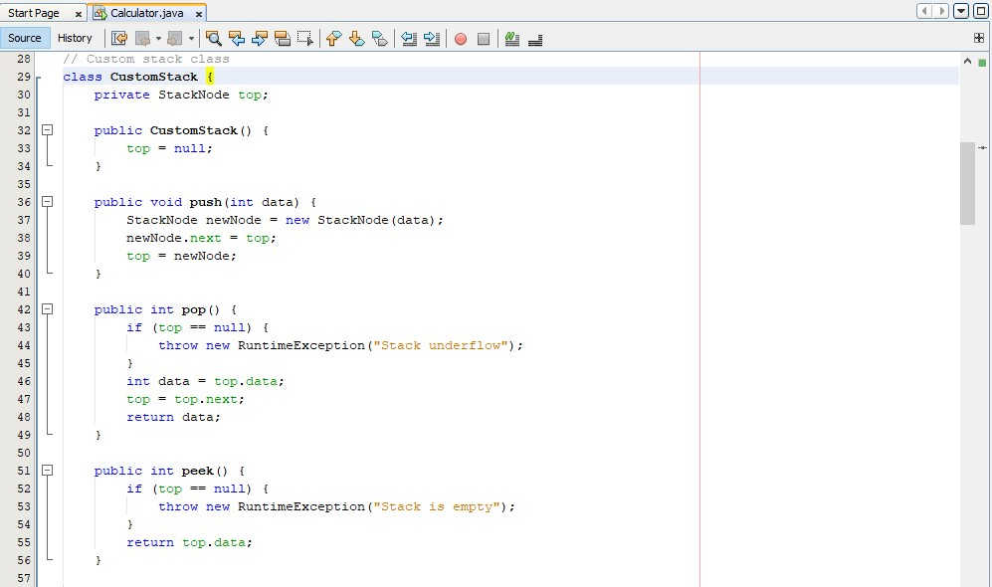
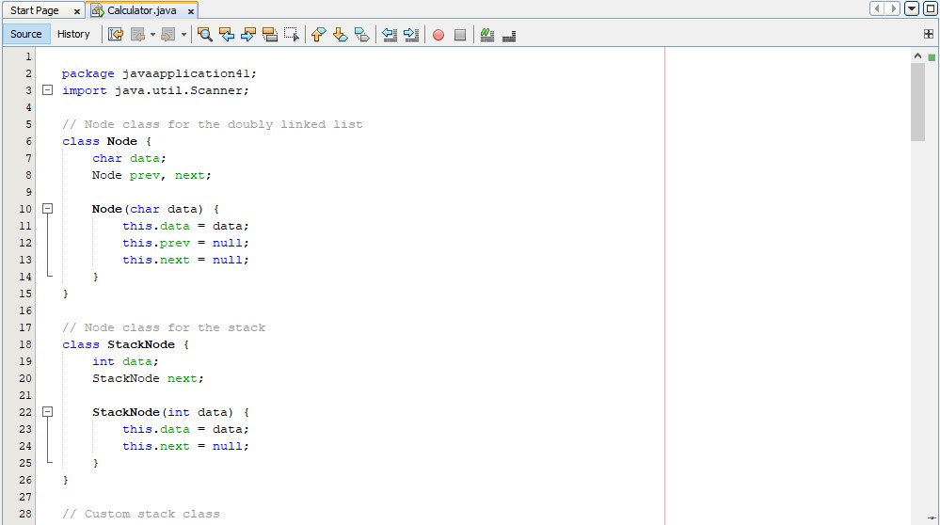
CODE :
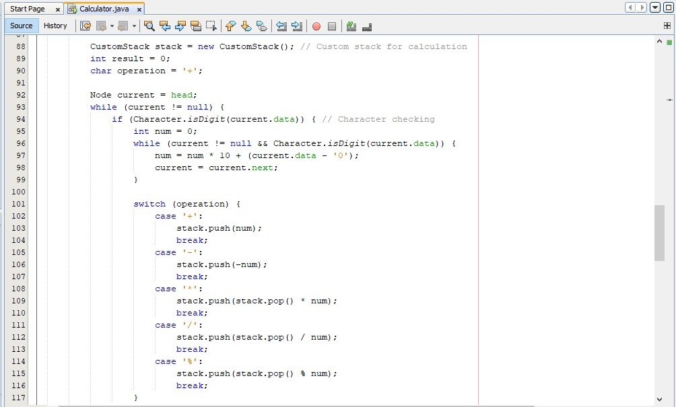
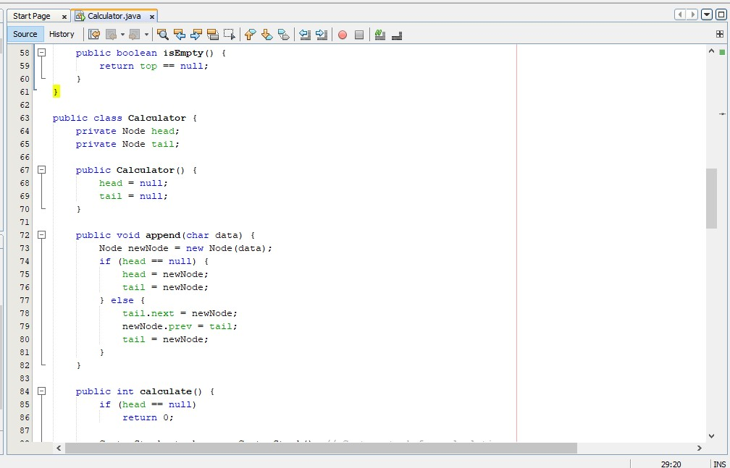
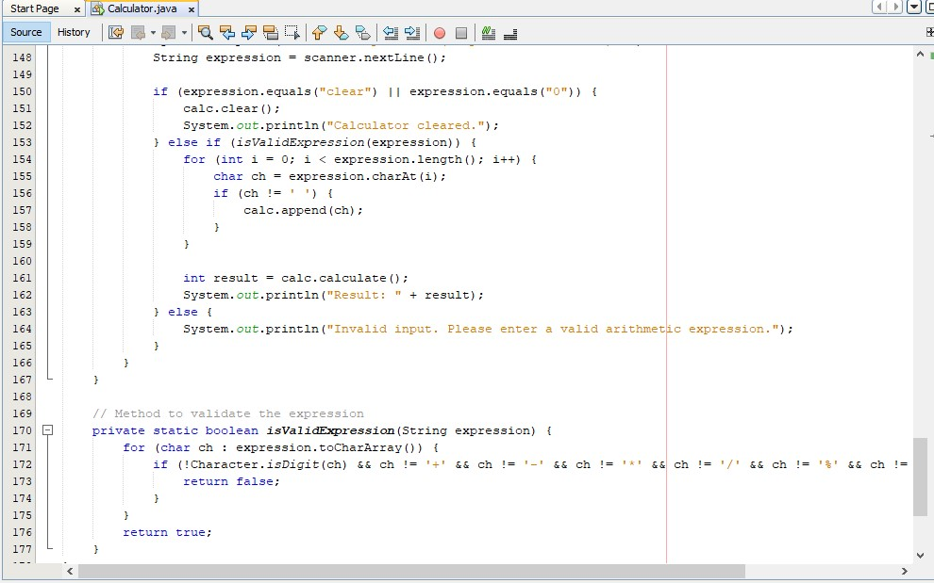
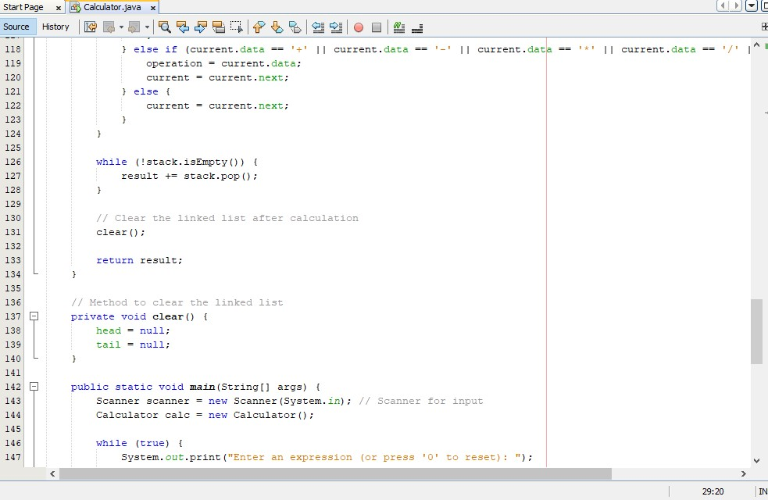
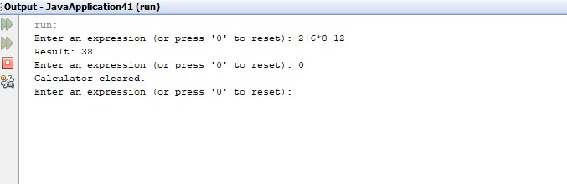
OUT PUT :

